HOW THE WEATHER API PROJECT RUNS

STEP 1:

Open the HYPER TERMINAL and the write the name of your root directory where all you files have been saved





STEP 2:

After reaching the root directory write down the following commands



The above command will show the following results

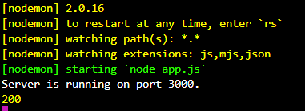

STEP 3:

Not open your browser and type the URL : localhost:3000



STEP 4:

The webpage will open and it will show this:



STEP 5:

In the search bar write the name of any location whose temperature you want to know

